

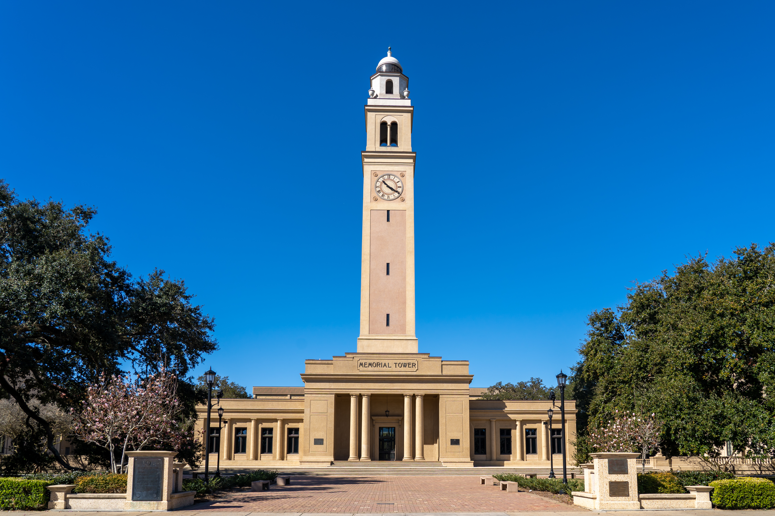

**Call for Applications: Ph.D. and Master Positions in Agroecosystem Sensing and Modeling at LSU and LSU AgCenter**

[**Dr. Peng Fu**](https://pengfuag.github.io/), Assistant Professor, at [**School of Plant, Environmental and Soil Sciences**](https://www.lsu.edu/agriculture/spess/index.php), [**Louisiana State University**](https://www.lsu.edu/) **(LSU)** and [**Louisiana State University AgCenter**](https://www.lsuagcenter.com/) **(LSU AgCenter)**, is seeking a highly motivated Ph.D. student to join the **agroecosystem sensing and modeling lab** (**ASML**) starting in **Summer** or **Fall 2025**. The ASML specializes in remote sensing, artificial intelligence, computational/process-based modeling, and statistical analysis to address critical issues in **food/energy security**, **sustainable agriculture**, **climate change**, and beyond.

**Research Opportunities**

Successful candidates will contribute to advanced monitoring capabilities to track agroecosystem changes and improved understanding of ecosystem dynamics. Potential research areas include:

(1) **advancing ecosystem sensing**: developing new datasets and/or algorithms relevant to agroecosystems (e.g., plants, soil, and water).

(2) **process-based modeling**: Quantifying and predicting agroecosystem services and dynamics (e.g., crop yield, water cycles, soil organic carbon).

(3) **AI, computational modeling, and statistical analysis:** Enhancing understanding of climate impacts on agriculture for sustainable agricultural practices.

Candidates will have the opportunity to collaborate with leading scientists in diverse fields such as **agronomy, genomics, hydrology, plant physiology, remote sensing, micrometeorology, soil science, ecology, geography,** and **environmental science** from **LSU, USDA, United Nations Food and Agriculture Organization (FAO)**, and other prestigious institutions. Graduate students in the ASML are expected to contribute to **the development of innovative research projects and proposals**.

**Benefits**

* **Stipend:** >$30,000/year (Doctoral students) or > $22,000/year (Master students)
* **Tuition Waiver:** Approximately $12,000/year for domestic students and ~$30,000/year for out-of-state and international students.

**Qualifications**

* A bachelor’s or master’s degree in relevant disciplines (remote sensing, soil science, plant physiology, ecology, geography, biogeochemistry, hydrology, earth system science, etc).
* Strong programming and quantitative skills (e.g., python, R, machine learning).
* Proficiency in English, both spoken and written.
* Applicants should meet the minimum requirements of LSU graduate admissions. Information on minimum requirements of LSU graduate admissions and application process/deadline can be found at <https://www.lsu.edu/graduateschool/admissions/requirements-deadlines.php>.

Prospective students are highly encouraged to contact **Prof. Peng Fu** ([pfu@agcenter.lsu.edu](mailto:pfu@agcenter.lsu.edu); [pfu@lsu.edu](mailto:pfu@lsu.edu)) first with the subject “**prospective Ph.D. student**”. Please include in the email:

* Unofficial transcripts,
* Test scores (e.g., GRE and TOEFL),
* A brief personal statement,
* Research publications (if any).